## Setup a Windsor aware controller factory

Have this already setup as the code is provided on the Castle Windsor website.

## MVC stuff

Create EmployeeService and Interface  


Create EmployeesController

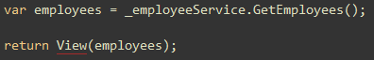

Return data to view

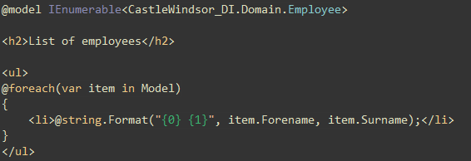

Redirect in default.aspx

## Add references to Windsor assemblies

Castle.core  
Castle.Windsor

## Tell Windsor about our types

* Use Installers to register types with container.
* Firstly, register our controller classes (based on IController).

*Add installer to an installers folder. With following fluent code to register controllers* 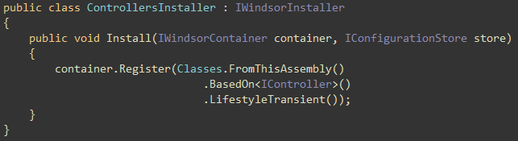

## Bootstrap Windsor

* Create container

*We do this in the application_onStart event in global.asax*

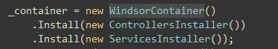

*Alternatively, you can use the following code which will look for all classes that inherit from IWindsorController (Windsor is optimised for a single call to Install)*

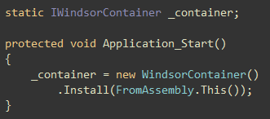

* Create Windsor controller factory

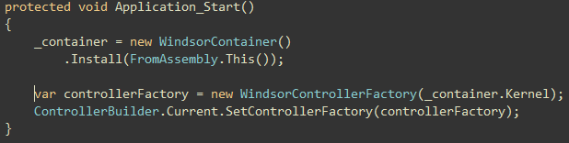

* Clean up!

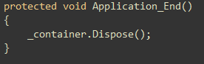

## Register Services

* Use another Installer to tell the container about a service.

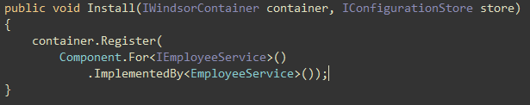

## Injecting parameters

* Passing parameters into the constructor.
* Assigning parameter to property.

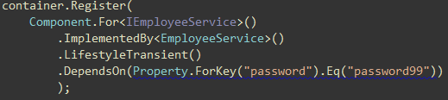

* Parameters from config (don’t forget to add the parameter to appsettings)

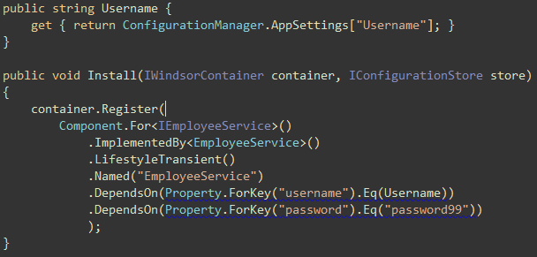

## Add a test

